**UCID: 2024510001 BATCH: A NAME: Atharva Vasant Angre**

**EXPERIMENT NO: 03**

**EXPERIMENT TITLE:** To implement Greedy Algorithm.

3.1 To Implement Greedy Algorithm (Job Sequence).

**Objective:**

1.To Implement Greedy Algorithm (Job Sequence).

**Program code:** -

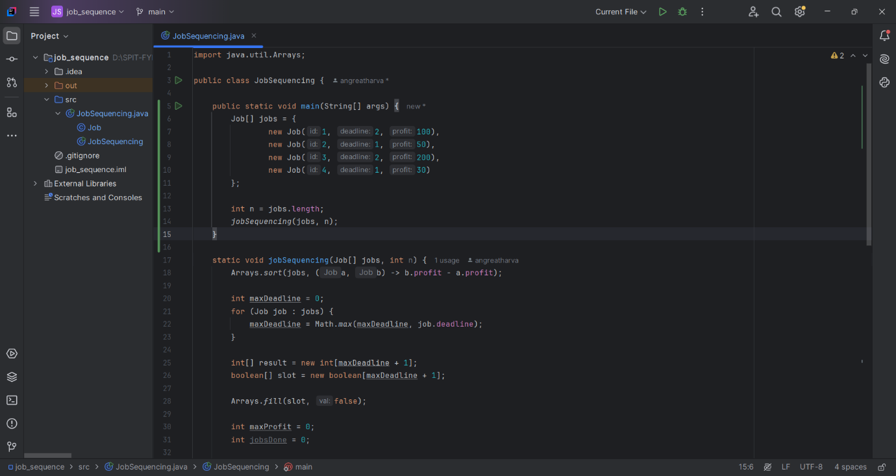**Job Sequence**

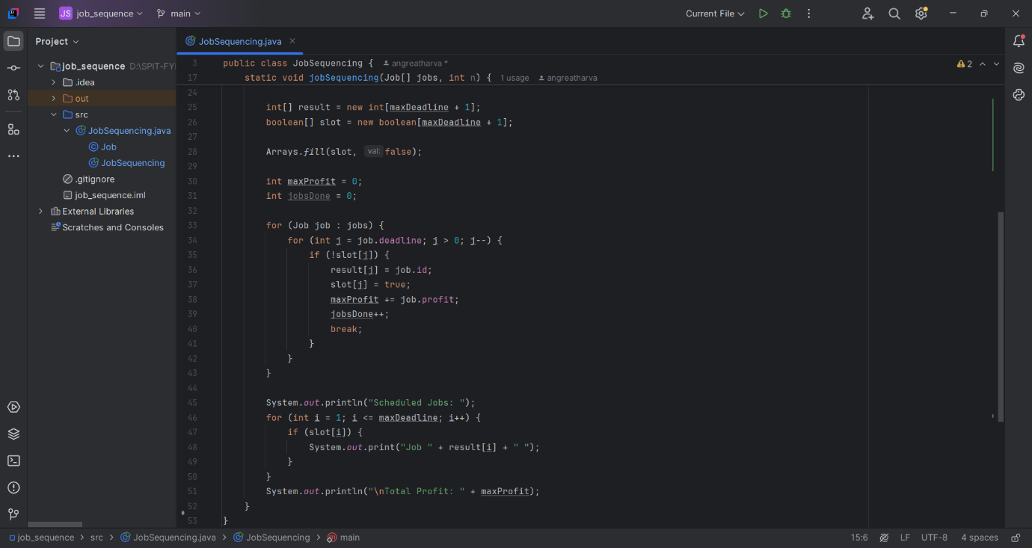

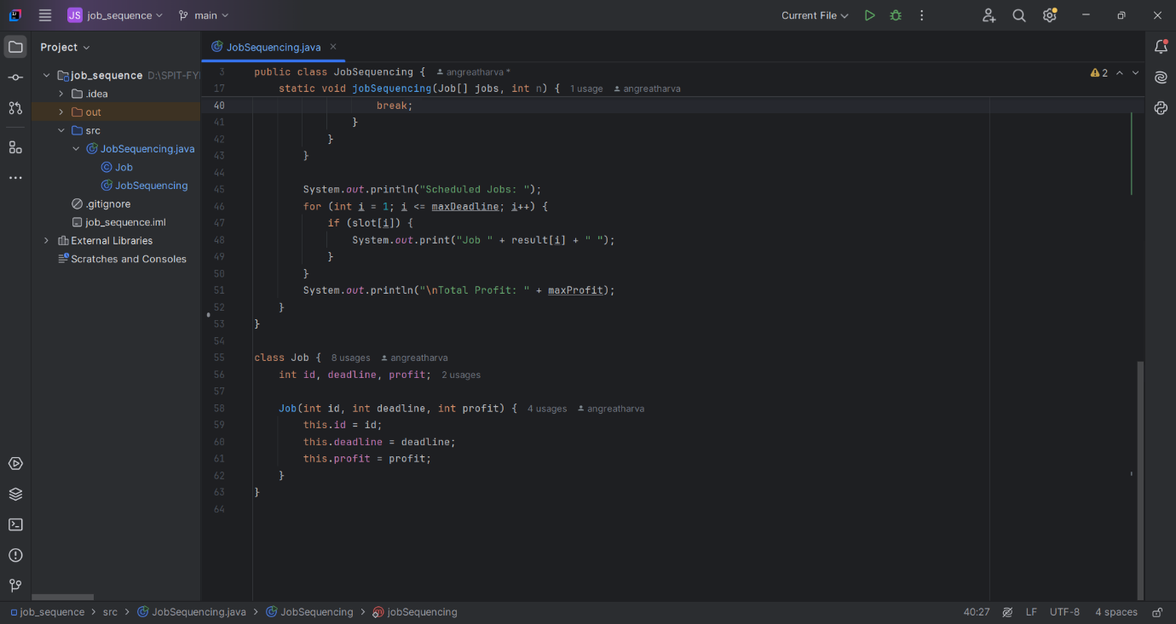

**Output:**

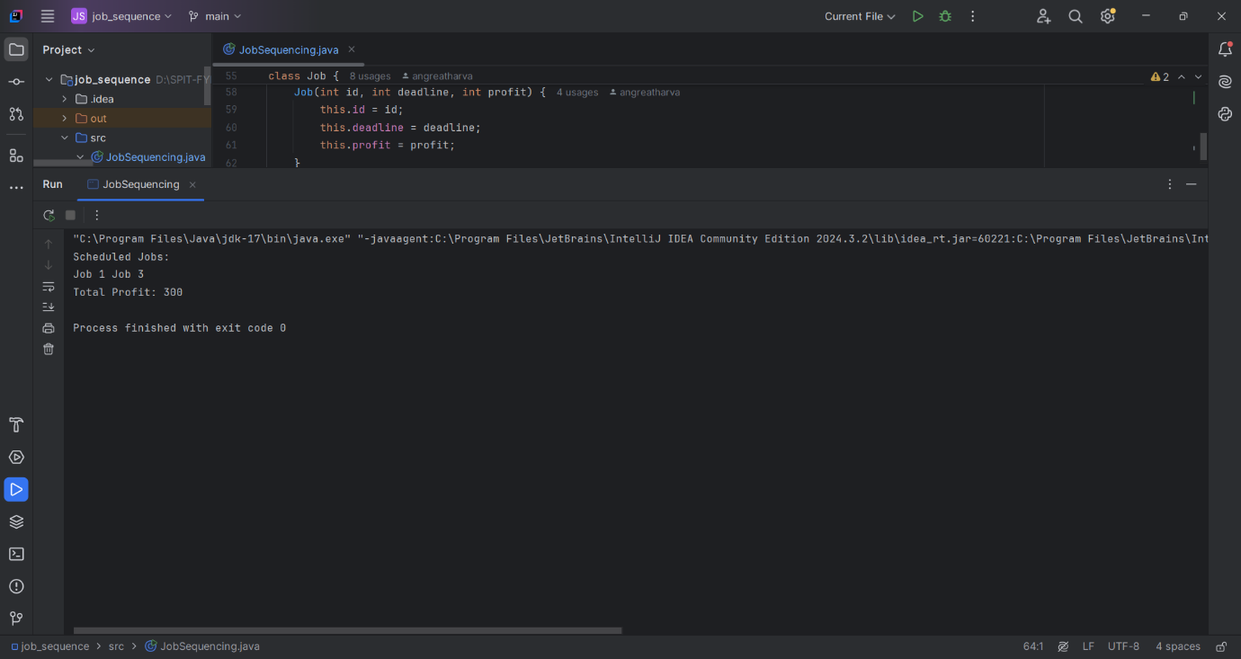

**Conclusion:**

The Greedy Algorithm for Job Sequencing helps in selecting jobs to maximize profit while meeting deadlines. It works by choosing the most profitable jobs first, ensuring an efficient schedule. This method is fast and useful for real-world scheduling problems. However, it may not always give the best solution in complex cases. Overall, it is a simple and effective approach for job sequencing.